Class Lab Assignment

Q 1 WAP using parameterized constructor with two parameters id and name. While creating the objects obj1 and obj2  
  
passed two arguments so that this constructor gets invoked after creation of obj1 and obj2

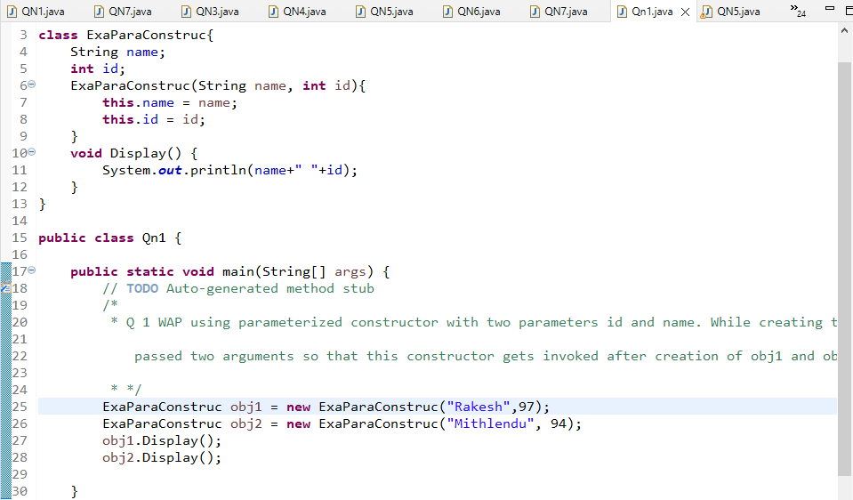

Output



Q 2 Write a program by creating an 'Employee' class having the following methods and print the final salary.  
1 - 'getInfo()' which takes the salary, number of hours of work per day of employee as parameter  
2 - 'AddSal()' which adds 10000 to salary of the employee if it is less than 50000.  
3 - 'AddWork()' which adds 5000 to salary of employee if the number of hours of work per day is more than 6 hours.

Solution

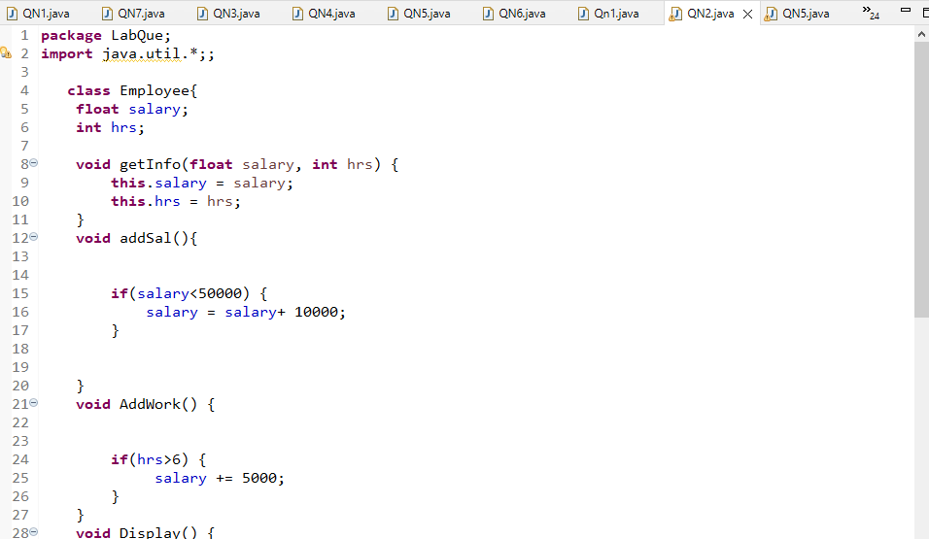

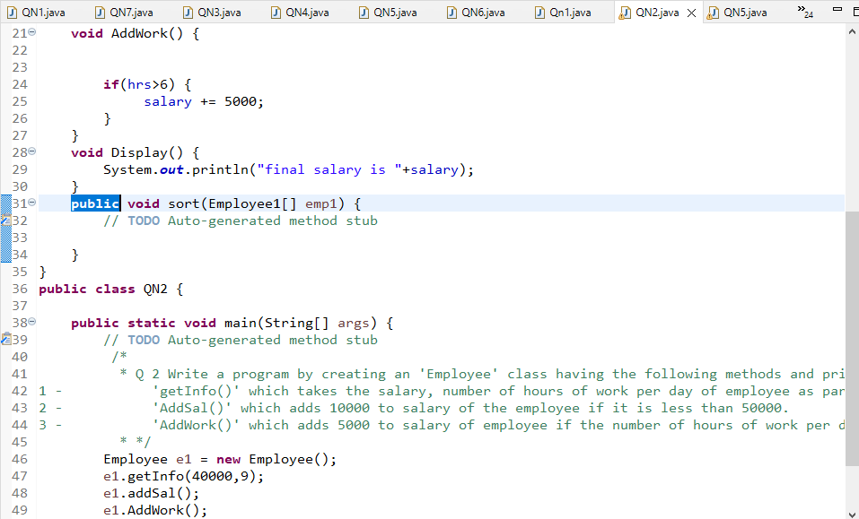

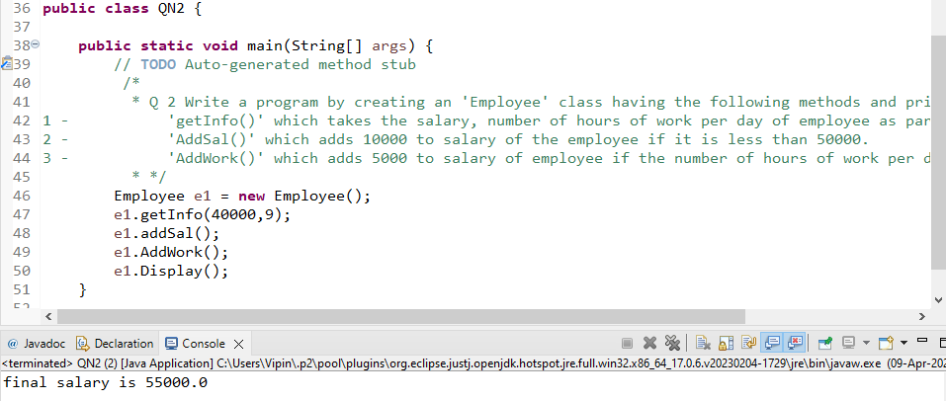

Q 3 Write a program to create a room class, the attributes of this class is roomno, roomtype, roomarea and ACmachine. In this class the member  
functions are setdata and displaydata.

Solution

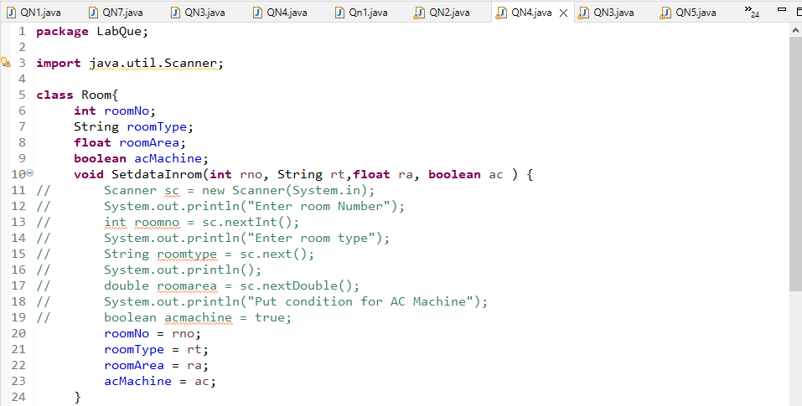

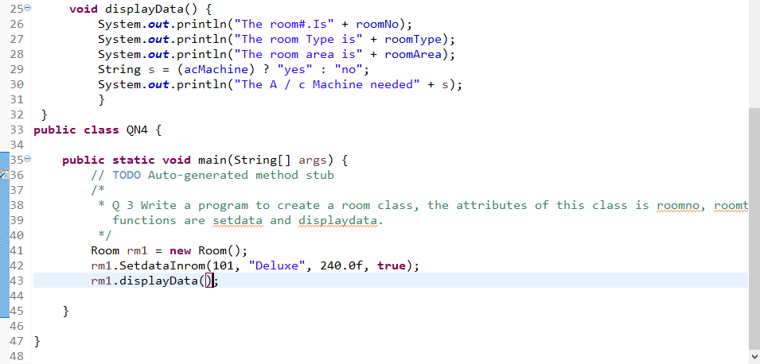

Output

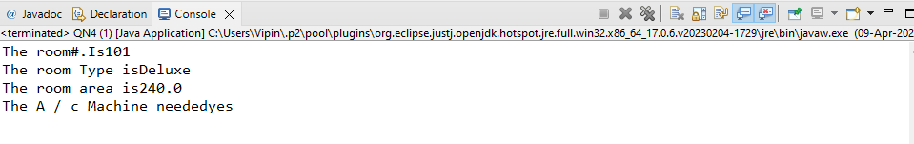

Q4 Write a program create a class Simpleobject. Using constructor display the message.

Solution

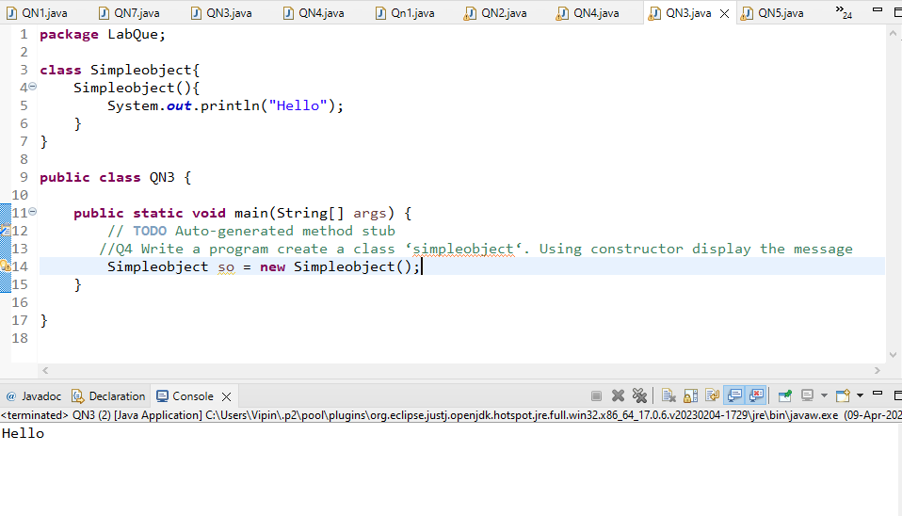

Q 5    Design a class to represent bank account. Include members:  
a.    Data members  
i.      Name of depositor  
ii.    Account number  
iii.    Type of account  
iv.    Balance amount  
b.    Methods  
i.    To assign value    
ii.    To deposit amount  
iii.    To withdraw amount  
iv.    To display name and balance .

Solution

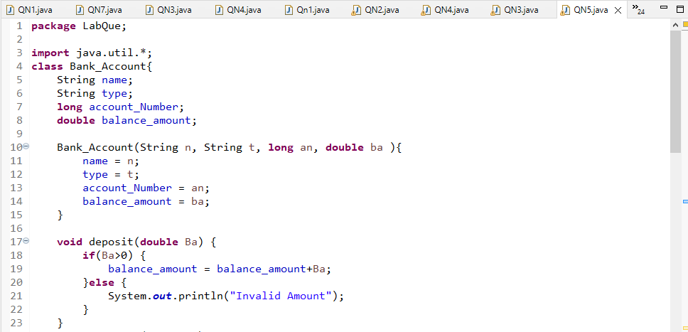

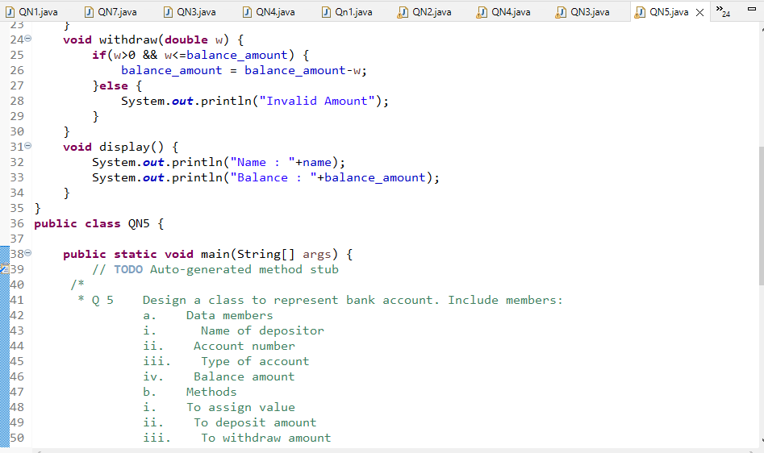

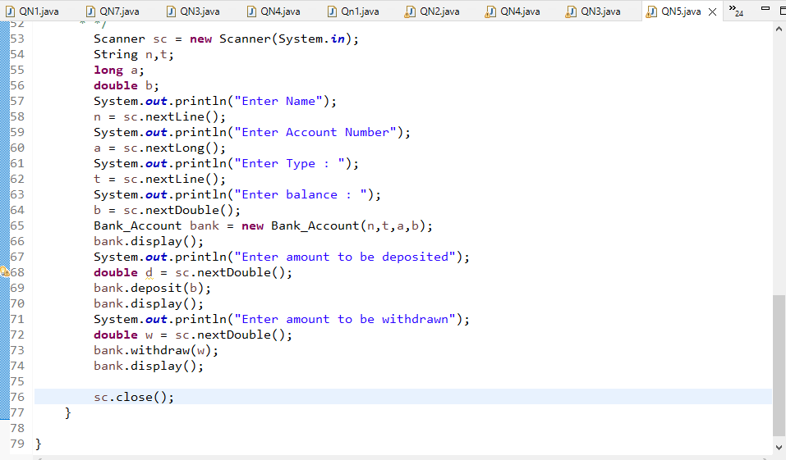

Output

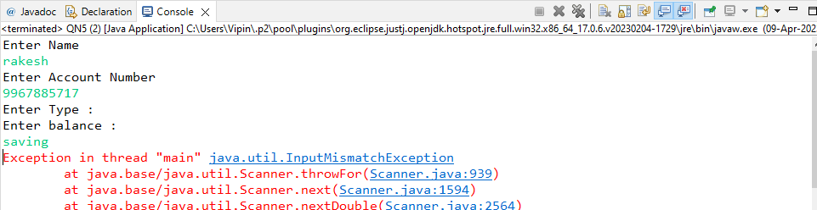

Q 6  Create a class named 'StudentRecord' with String variable 'sname' and integer variable 'roll_no'.  
Assign the value of roll_no as '2' and that of name as "John" while creating an object of the class Student.  
and using display method show all values on console

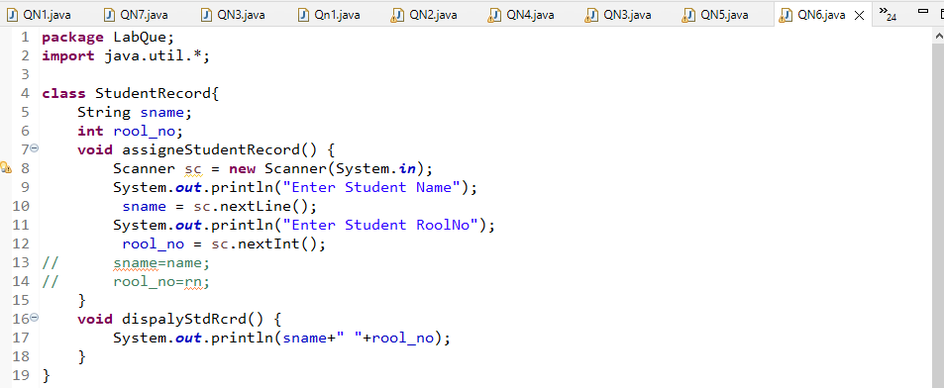

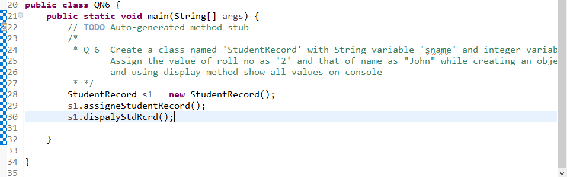

Output

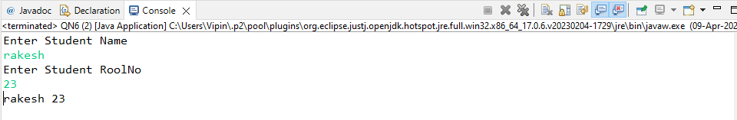

Q 7 wap to ask 6 employee record from  user using get and display method show record on console after performing sorting on record on basis ofemployee id.

Solution

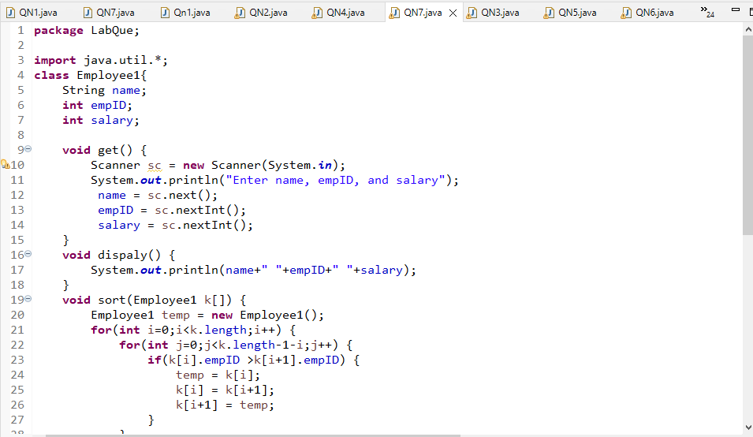

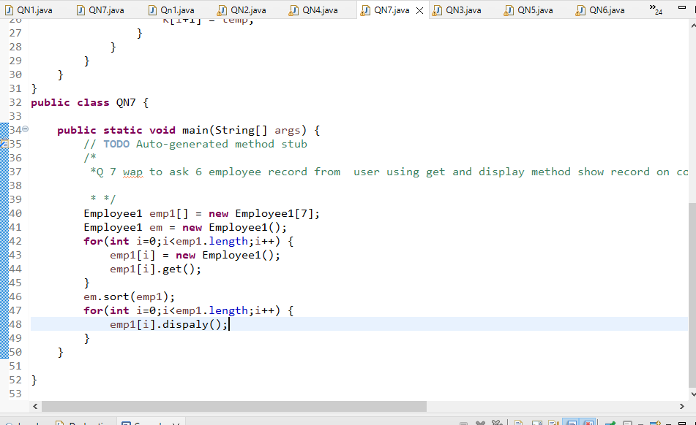

Output

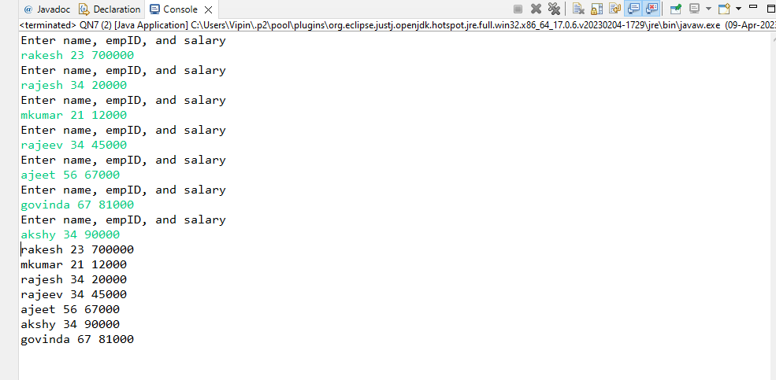

Q 8  Wap to perform addition of two three and fourth integer numbers using functions  
(use polymorphism)

Q 9 Write a JAVA program which contains a method square() such that square(3) returns 9,  
square(0.2) returns 0.04.

Solution

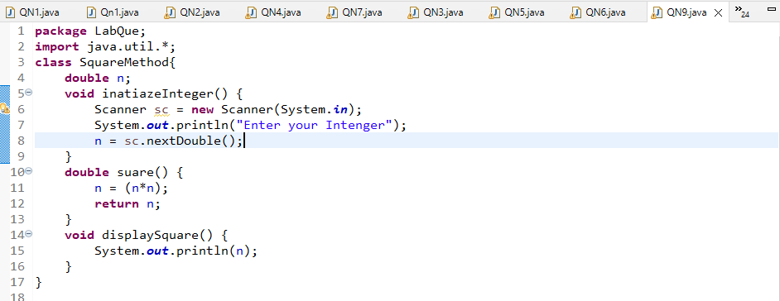

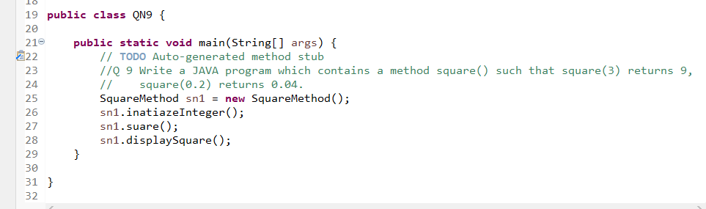

Output

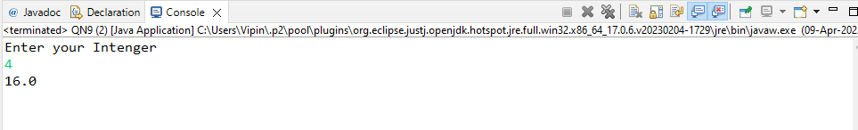

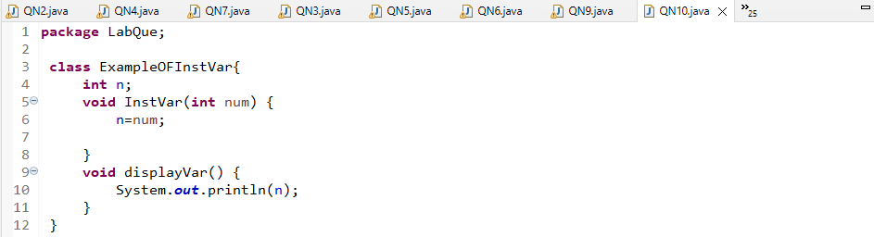

Q 10/* * Design class and declare instance variable of integer type  
 *    
 * store value to instance variable during object creation .  
 *  
 * in case if we do not pass any value to during object creation then zero will be stored in it  
 *  
 * create display method to display instance variable  
 */

Solution

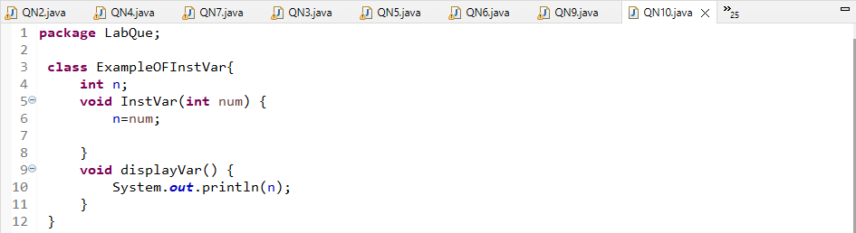

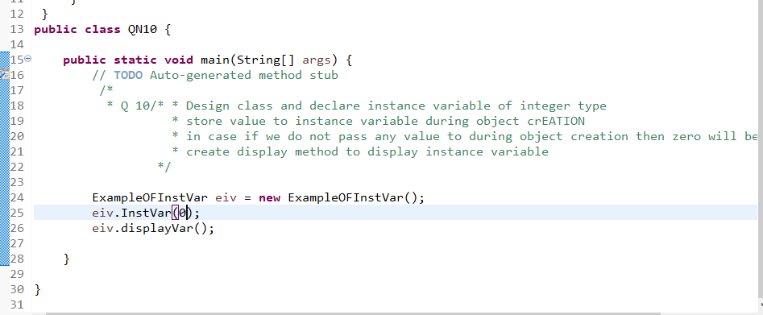

Output

